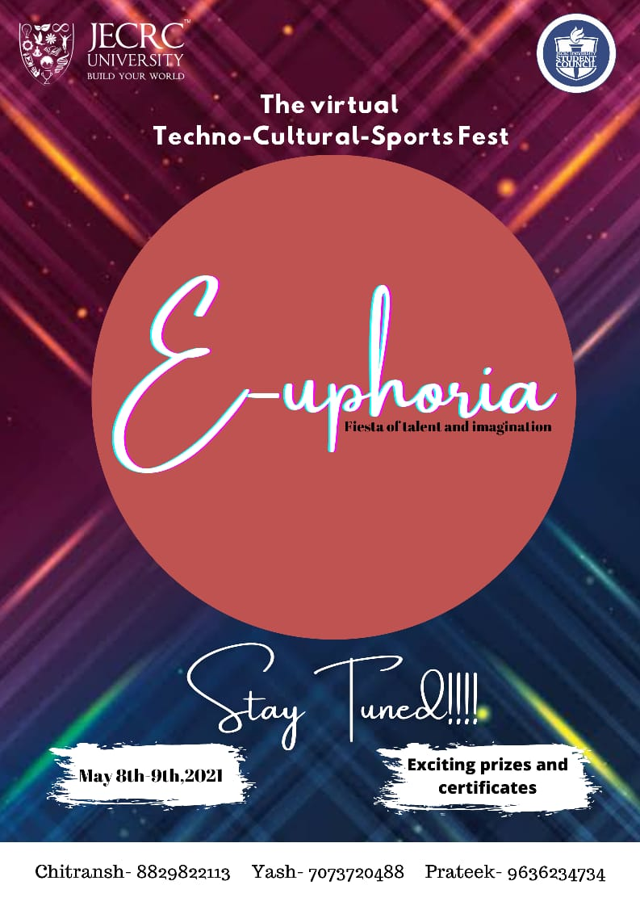

**RULEBOOK**

**OF**

**E-SPORTS EVENTS**

# **VALORANT**

### Valorant Gameplay

Valorant is a team-based tactical shooter and first-person shooter set in the near future. Players play as one of a set of agents, characters designed based on several countries and cultures around the world. In the main game mode, players are assigned to either the attacking or defending team with each team having five players on it. Agents have unique abilities, each requiring charges, as well as a unique ultimate ability that requires charging through kills, deaths, or spike actions. Every player starts each round with a "classic" pistol and one or more "signature ability" charges. Other weapons and ability charges can be purchased using an in-game economic system that awards money based on the outcome of the previous round, any kills the player is responsible for, and any actions taken with the spike. The game has an assortment of weapons including secondary guns like sidearms and primary guns like submachine guns, shotguns, machine guns, assault rifles and sniper rifles. There are automatic and semi-automatic weapons that have a shooting pattern that has to be controlled by the player to be able to shoot accurately. Different agents allow players to find more ways to plant the Spike and style on enemies with scrappers, strategists, and hunters of every description. It currently offers 15 agents to choose from. They are Brimstone, Phoenix, Sage, Sova, Viper, Cypher, Reyna, Killjoy, Breach, Omen, Jett, Raze, Skye, Yoru, and Astra.

# **1. VALORANT RULES AND REGULATION**

### 1.1. PLAYER ELIGIBILITY

* Any players banned by Riot are not allowed to participate in the tournament.
* Participants must use their own Riot account.
* Refer to general rules for more information.
* Players in a team should be from the same institution. Violation of this may lead to disqualification.
* Team should be made of minimum 5 players or maximum 6 players (one substitute).

### 1.2. EQUIPMENT

* All players must have their own computer, internet connection and gaming peripherals to compete in the online tournament.
* The PC application used will be VALORANT developed by Riot Games.
* The tournament organizer will not take responsibility for any teams who are not able to set up their peripherals before the allocated tournament start time and will penalize the teams as per rules.

1.3. TOURNAMENT FORMAT

* Game Mode: 5v5 Standard Mode
* Cheats Disabled
* Tournament Mode On
* Overtime win by two
* The map rotation will be different in upper and lower brackets.
* Upper Bracket: Each match will use a different map
* Map will be chosen by pick/ban method by the teams.
* Upper Bracket and Grand Finals matches will be Best of 3. Lower Bracket will be Best of 1.
* Coin toss will be done using Battlefy’s in-built coin flip system. Winner of the coin toss will choose to attack or defend and to pick/ban the first map.
* During the match the team should be present on the DISCORD server in the given channel (link of the server will be provided.)
* All the query can be asked on the DISCORD server.
* According to the registrations bracket will be made.
* Initially all the matches will be knockdown based.
* Semi final and final will be best of three.

### 1.4. TECHNICAL ISSUES/GLITCHES

* Each team is given a maximum pause time of five (5) minutes if a player disconnects.
* In the event of a server crash, players will remake the game with the same character selections.
* The tournament organizer will not bear any responsibility for any losses resulting from lag on the player’s end. Players are advised to check if the network is stable before the start of the game.
* Glitch: Creating or exploiting game bugs intentionally to gain advantage over your opponent is prohibited and may result in disqualification. If you encounter a team using a glitch please contact the tournament admins immediately. It is recommended to take a screenshot or recording of the glitch or exploit being used. If a glitch is inadvertently encountered by either team (such as being locked out of ability usage), if the match is not streamed, the affected player will need to attempt to reconnect to the match. If that does not resolve the error, then the affected player will need to play through the remainder of the match. If the match is being broadcasted, the match will be immediately restarted upon confirmation of the glitch.

### 1.5. RESULT REPORTING

* If required, the winning screenshot must be submitted by the winning team.
* Any disputes in score should be submitted to the tournament organizer within 10 minutes once the match ends.

**CHESS :**

Chess is an [abstract strategy game](https://en.wikipedia.org/wiki/Abstract_strategy_game) and involves n[o hidden information](https://en.wikipedia.org/wiki/Perfect_information). It is played on a square chessboard with 64 squares arranged in an eight-by-eight grid. At the start, each player (one controlling the white pieces, the other controlling the black pieces) controls sixteen [pieces](https://en.wikipedia.org/wiki/Chess_piece): one king, one queen, two rooks, two knights, two bishops, and eight pawns. The object of the game is to checkmate the opponent's king, whereby the king is under immediate attack (in "check") and there is no way to remove it from attack on the next move. There are also several ways a game can end in a draw.

**Rules for chess tournament :**

The tournament will be conducted in KNOCKOUT style. Tournament format will be finalized after the possible number of participants is determined.

The players will be paired online on Chess.com interface and for communication on DISCORD , clock time for initial rounds will be 10 min (each) so each game will roughly take a maximum of 20 min. clock time might be the same or little longer for subsequent rounds.

**All standard rules for the game apply. these are the highlights:**

**All players:**

**Must be able to do the following:**

- Players should join the DISCORD server (link will be provided).

- Role will be provided in the DISCORD server according to the registrations.

- Matches will be conducted on CHESS.COM and player should be present on discord at the time of the match.

- Properly move all of the chess pieces

- Understand pawn promotion.

- Understand rules for “advanced” moves: Castling and en passant capture (note: please ask the organizer in case of any confusion about en passant rule )

- Understand Check and the ways to get out of check (move, block, capture)

- Understand Checkmate

- Understand the “touch-move” rule

- Understand 50 moves draw rule i.e. the game can be claimed drawn after 50 moves if there are no pawn moves or no captures.

- Understand 3 fold repetition rule. the game can be claimed drawn if the exact same position is repeated thrice.

- No outside assistance during games is allowed.

- Announcements will be on DISCORD server.

- In case of any confusion/disputes talk to the tournament organizers.

**I BET YOU**

I Bet You is a fun and challenging event. It will consist of two teams who will be betting over each other to perform various fitness challenges and fun questionnaire. For every winning bet, the respective team will be awarded points and points will be awarded to the opponent team if the team is unable to perform the claimed bet.

The challenges will include plank, push-up, fun questionnaire related to sports and various other fitness challenges. So all the gym freaks and sports enthusiasts must gear up and be ready to CHALLENGE!

**GUIDELINES**

* It is a team game. Each team will consist of 2 players, a performer and a leader.
* This will be a knockout tournament.
* Match will take place between two teams. Each team will be given a challenge by the host on which the team will be betting on each other.
* Any misconduct will not be tolerated and the team may be disqualified.
* For every winning bet the points will be awarded to the respective team and for every loosing bet the points will be awarded to the opponent team.
* The event will take place on a virtual platform ZOOM.

**IPL AUCTION**

About:  
An event for everyone who not only just loves the game of cricket, but also analyses it to the limit. This event makes you the don of the hat of a bidder. You need to manage your budget and you can strategize to make the best possible team competing against other opponents who will give you a run for your money, quite literally. If you love cricket, if you have followed IPL and if you can mix common sense with passion into your bidding strategy, this event is a must for you.  
  
Round 1: Online Quiz: 20 minutes duration.  
The quiz will contain questions only from Cricket. It will be an elimination round.  
Round 2: Online meet Round: 3-4 hours duration.  
The final teams will compete in a live auction of players in ZOOM metting. Each team will be given a fixed budget which will be used for the auction. The aim will be to build a squad that maximizes the total attribute score of the team.  
  
1. Rating Points have been given on the basis of the player’s last year’s International T20performance (includes IPL and other Domestic Tournaments). Select your players accordingly.  
2. Team composition: At Least 3-Batsmen , 3-All-rounder, 2-Wicketkeeper, 4-Bowler.  
3. Maximum 5 Foreign players.  
4. Squad Length 12-15 players.  
5. Budget 60 Crores.

Rules:  
1. A team must comprise of 2-3 members.  
2. Team members must be college students.  
3. A team member cannot register in more than one team.  
4. Multiple teams from institutes are allowed and encouraged  
5. In case of discrepancies, decision of the judges/event organizers will be final.  
6. Organizers reserve the right to change the Timelines.

Calculation of Attribute Score

1. Once the Auction round is over each of the 8 teams will have to submit their playing 11 which consists of the follows-

* 5 Bowling options.
* 1 Wicket-keeper.
* Maximum of 4 Foreign Players.
* Captian- Rating Points 3x.
* Vice-Captain- Rating points 2x.
* Other Players of Playing 11- Rating points 1.5x
* Substitutes players- Rating Points 1x

1. After this rating points of each player will be summed up according to their category and the resultant would be the Attribute Score of the team.

Judging Criteria:

1. The teams which will clear elimination round (online quiz) will proceed to the next phase i.e. the Online meet auction round.  
2. In auction round, the team which will have the highest attribute score will be judged as the Winner of the event and subsequently the second highest attribute score will be proclaimed as Runnersup of the event.

Attractive cash worth to be won by the winner and runner-up team